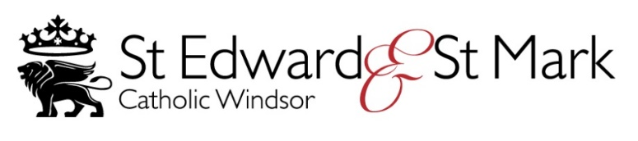

APPLICATION FOR FIRST RECONCILIATION AND
FIRST HOLY COMMUNION 2021

Names of parents:

Name of child: Surname of Child

Baptised at:

On: (Date)

(Baptism Certificate must be supplied)

Home Address:

Phone No: Mob No:

Email:

Date of birth: School:

Please complete this form online, save a copy and email it as an attachment to:
parishoffice@catholicwindsor.org

I / We attend Mass weekly at St Marks*/St Edward's * (please delete as necessary)*

I / We would like (Name of child)
to make HIS */ HER * First Reconciliation and First Holy Communion in 2021.

Signed: Name:
GDPR Information
Information provided on this form, together with all other personal data held about these individuals by the Parish and the Diocese of Portsmouth, is processed in accordance with the Diocese's Privacy Notice available on line or from St Edwards Parish Office.

